**GIT EXERCISE ASSIGMNET 1**



**1.Create a local "repository" with project name cloudethix_devops_yourname with a git tool**.

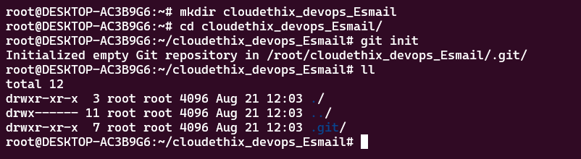

**2.Create 3 files named hello.txt , world.txt ,cloudethix.txt. Add some data in the files. Then add those files to the staging area. And then commit those to your local repository.**

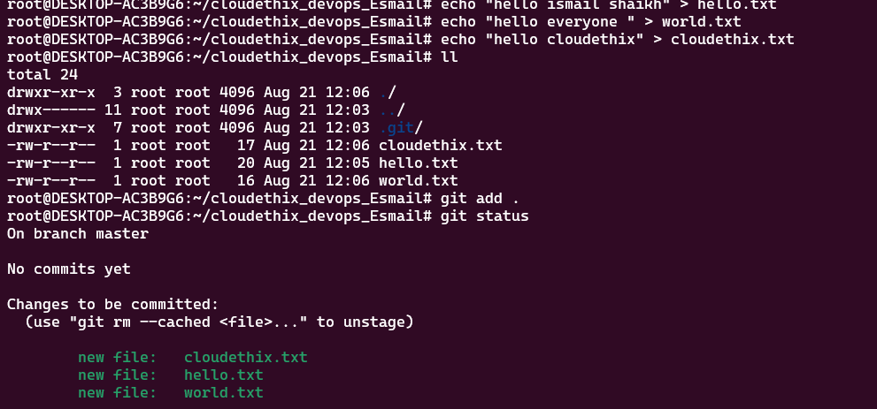

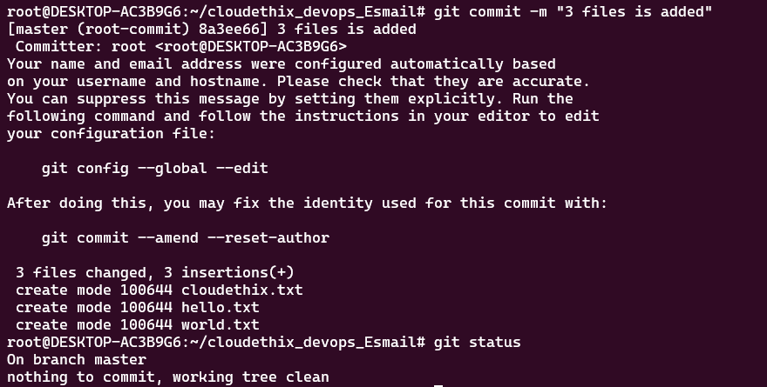

**3.Delete cloudethix.txt file from your system and recover it with git.**

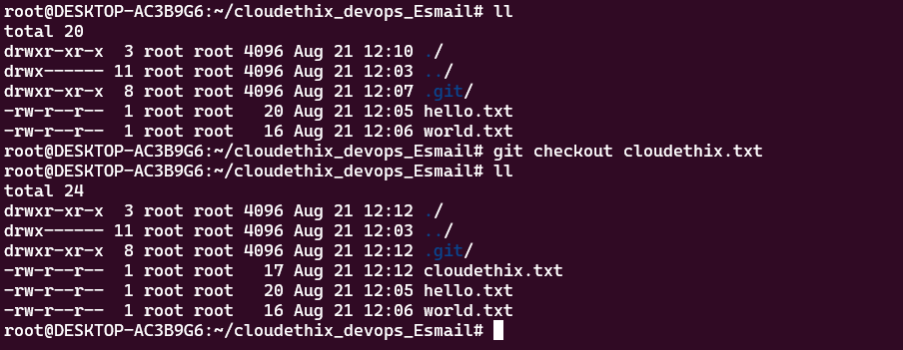

**4.Create 4 branches with GIT develop, release, hotfix , feature.**

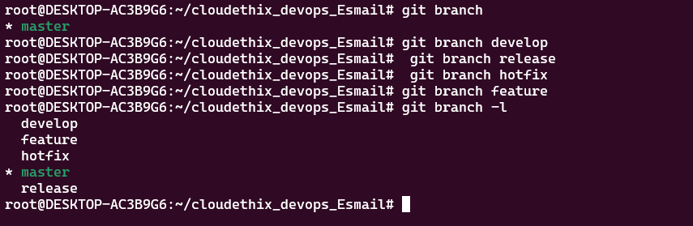

**5.Prove that data in branch develop and release branch is not the same by committing some files to both the branches.**

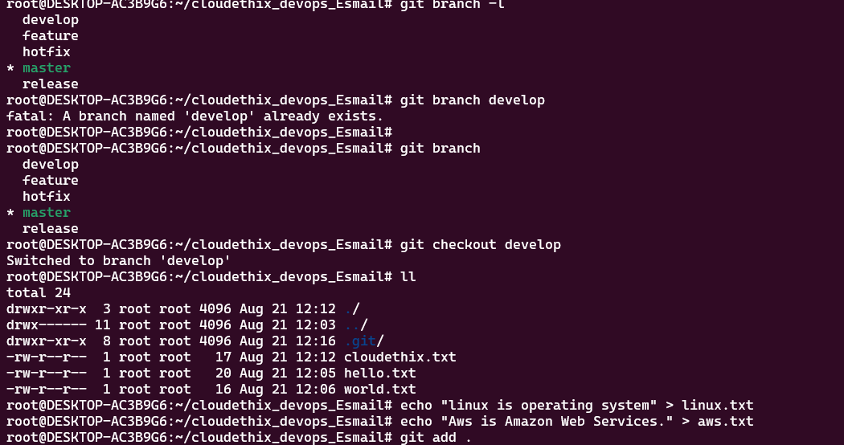

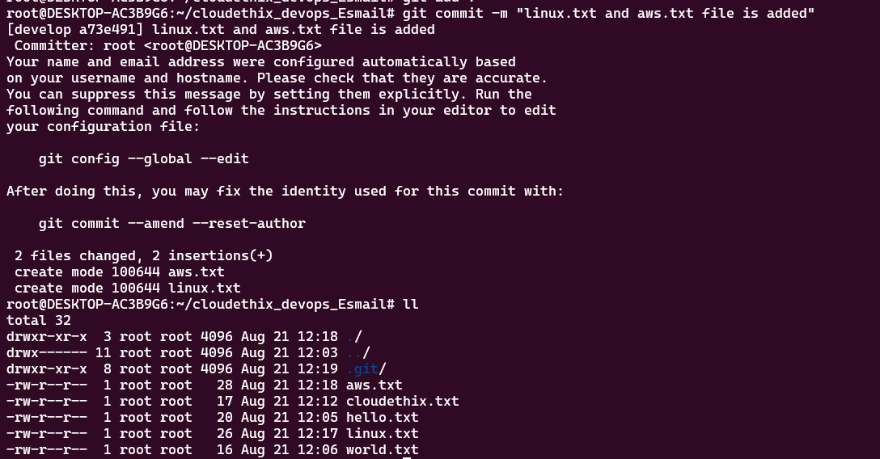

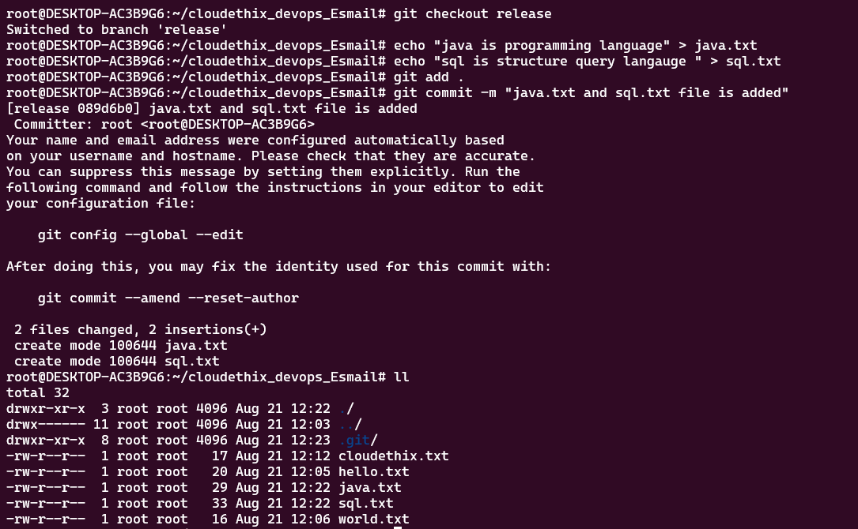

**Now you see that both branches data is not same**

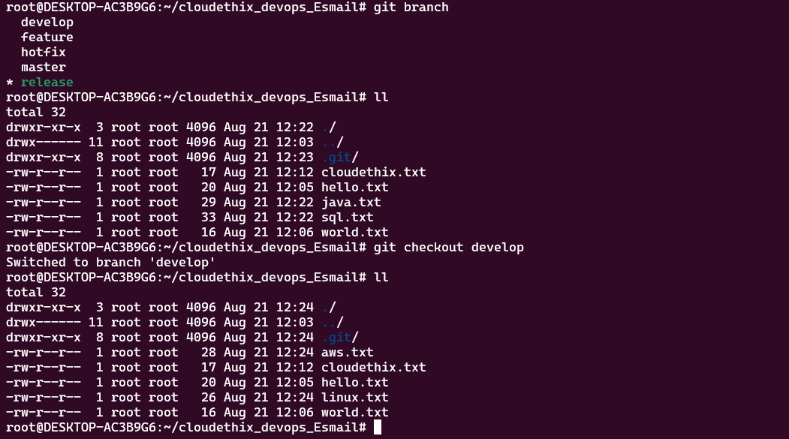

**6. Add any 3 files to the hotfix branch and merge the hotfix branch with master branch.**

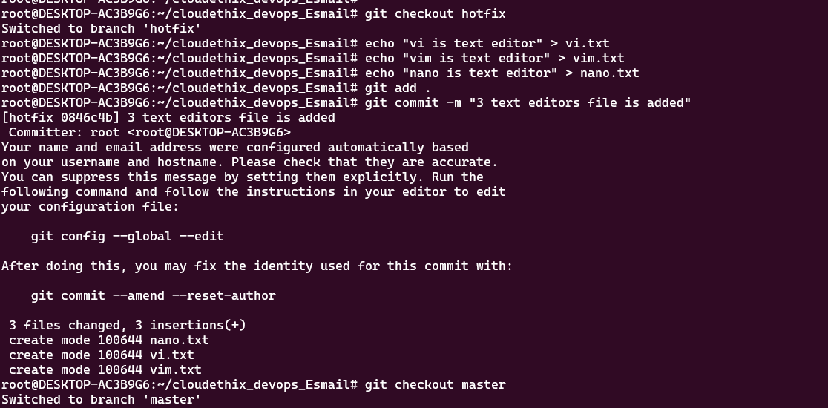

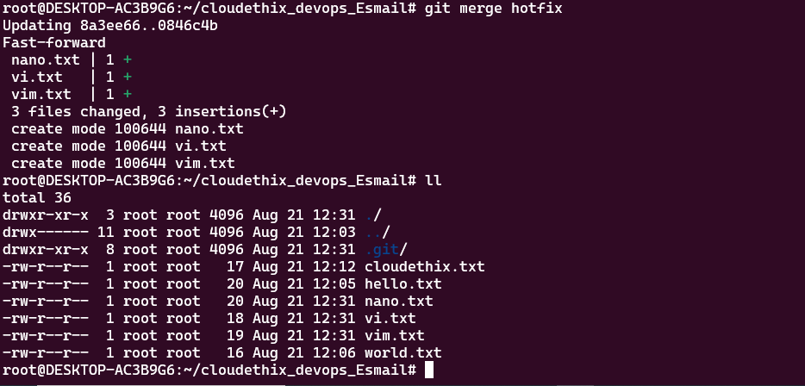

**7.Once a hotfix branch is merged , check the logs and then delete the hotfix branch.**

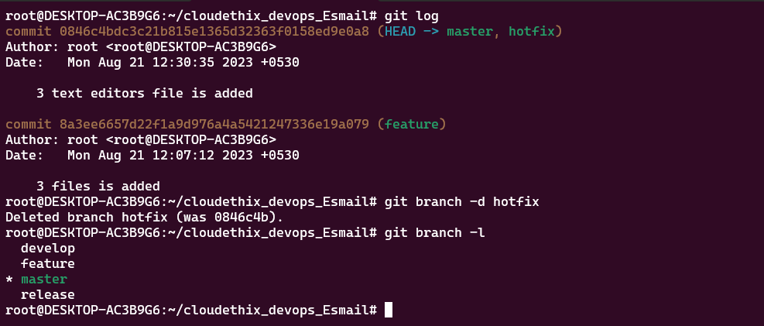

1. **Create one repository to GITHUB then push your master branch to the remote repository.**

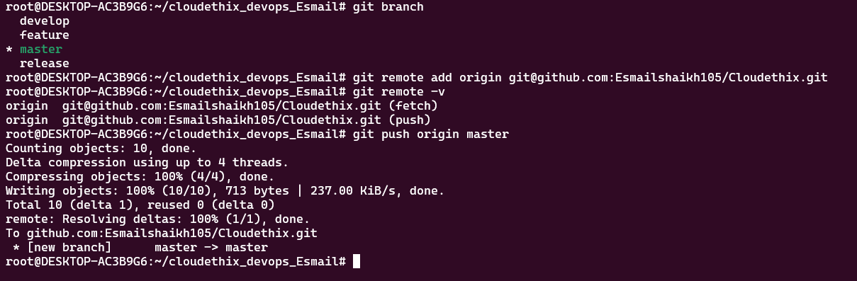

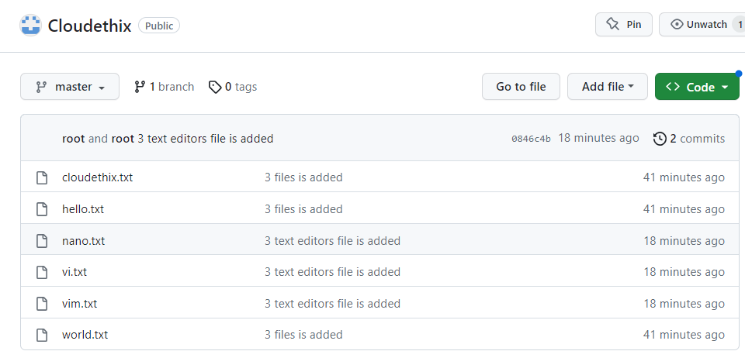

1. **Clone the remote repository to your local system and then create any 3 directories in the repository. Then create 3 files in each directory. Then commit the changes to the remote repository.**

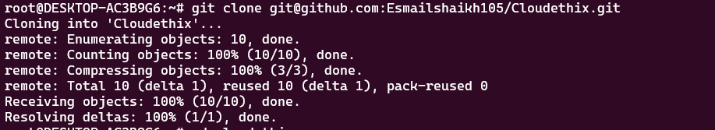

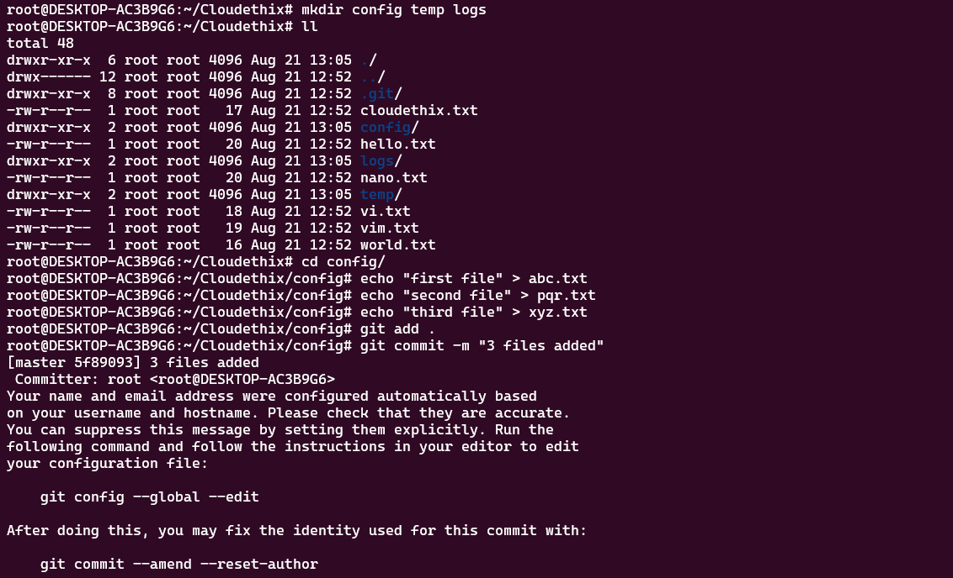

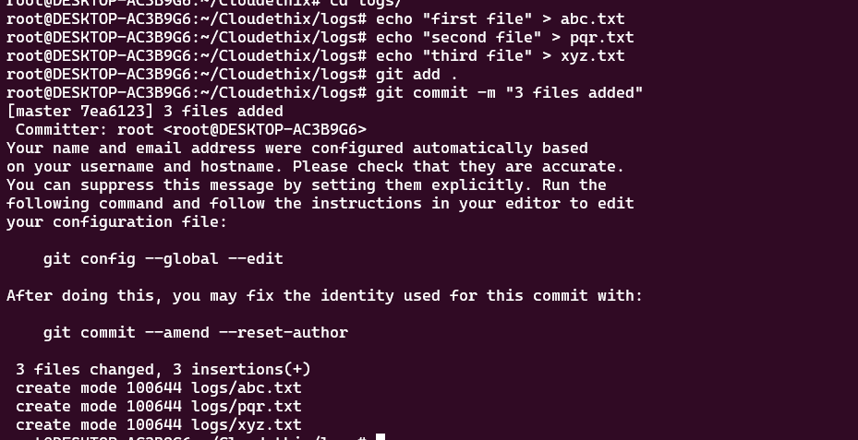

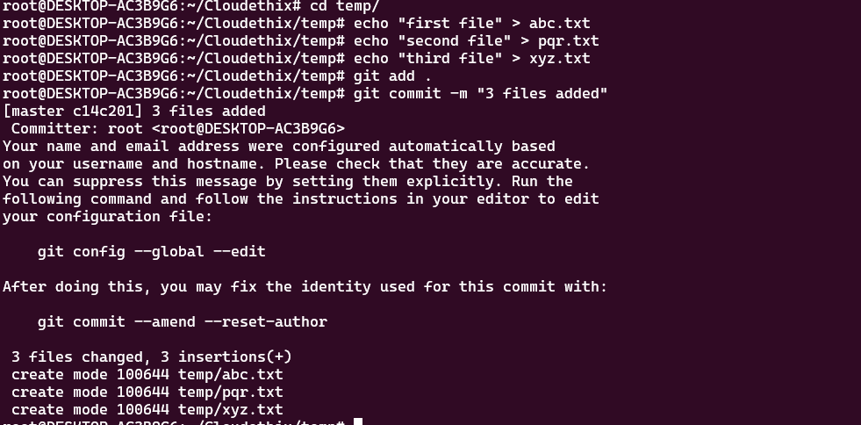

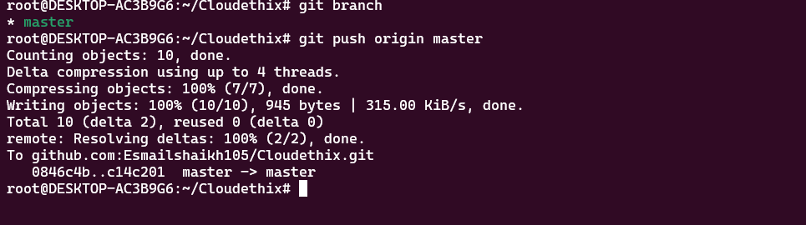

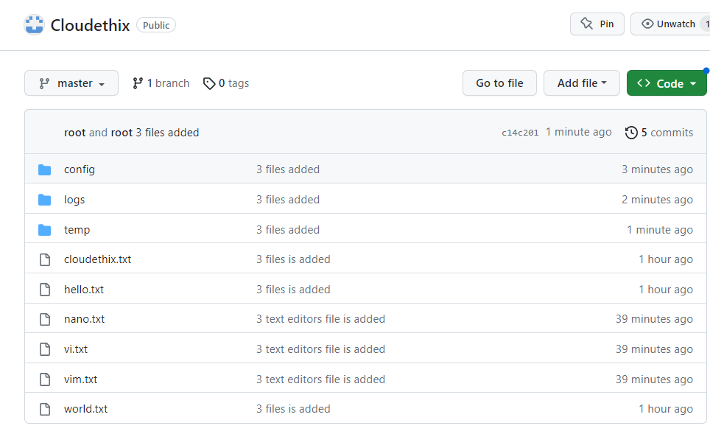

1. **Create a new branch to the cloned remote repository, add some more files , commit and push the new branch to the remote repository.**

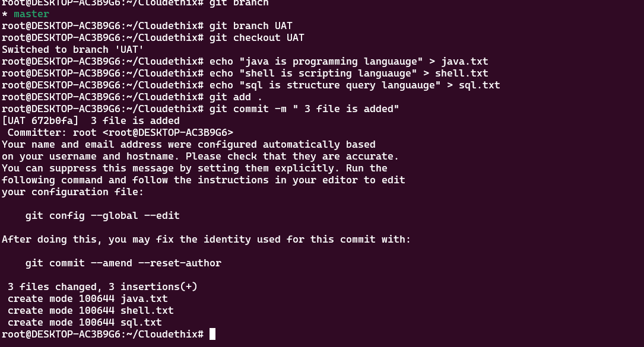

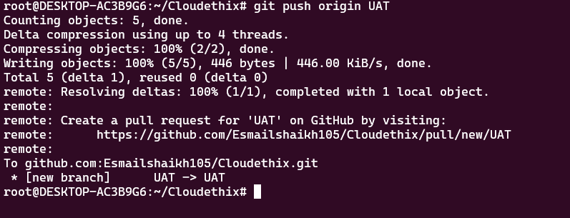

[https://github.com/Esmailshaikh105?tab=repositories](GIT ASSIGNMENT 01.docx)

